|  |  |  |  |
| --- | --- | --- | --- |
| Name | Iteration | Dates | Comments |
| Mel Chi | 1 | 9/17-9/24 | Added Test Cases for Registering, Login, Password |
| Mel Chi | 3a | 10/1-10/8 | Test cases for the Kitchen Staff and Admin Pages |
| Mel Chi | 3b | 10/8-10/15 | Updated Test Cases for Admin Pages  Started conversion to an excel file per results on Thursday’s Presentation |

QA • Quality Assurance through System Testing o Test case description • Environment • Steps • Precondition • Postcondition o Basic tests o Alternate path tests o Exception tests o Exhaustive and Random testing

Test Case Kitchen Staff Login

1. Login with information Chef/Chef

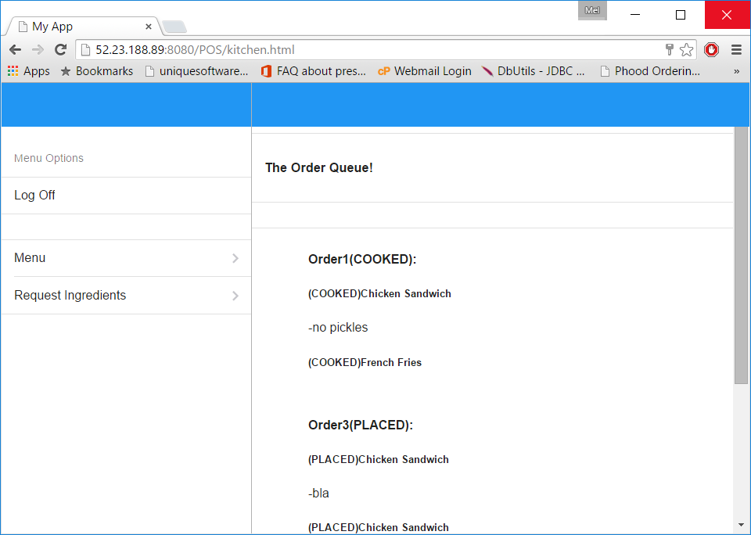

Test Case - Kitchen Staff Order in Progress

1. Slide order right to set in progress

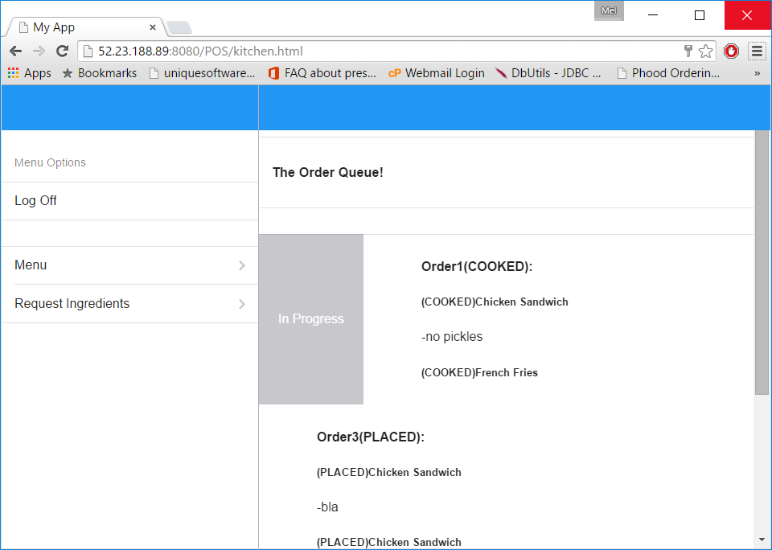

Test Case - Slide right to Say done

1. Slide right to be finished.

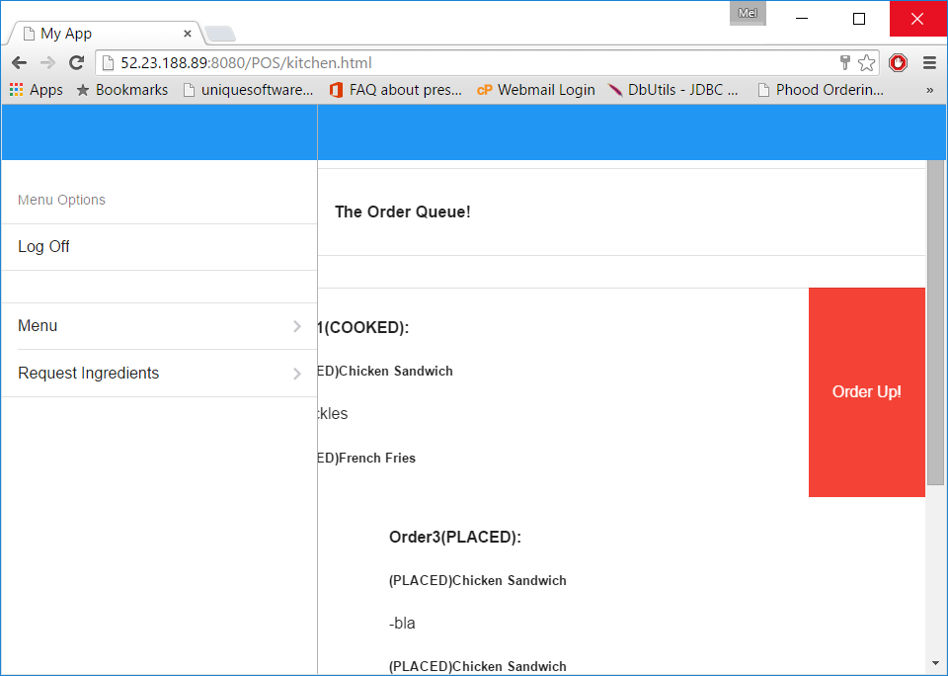

Test Case - Admin Login

1. Click on login with information Admin//Admin

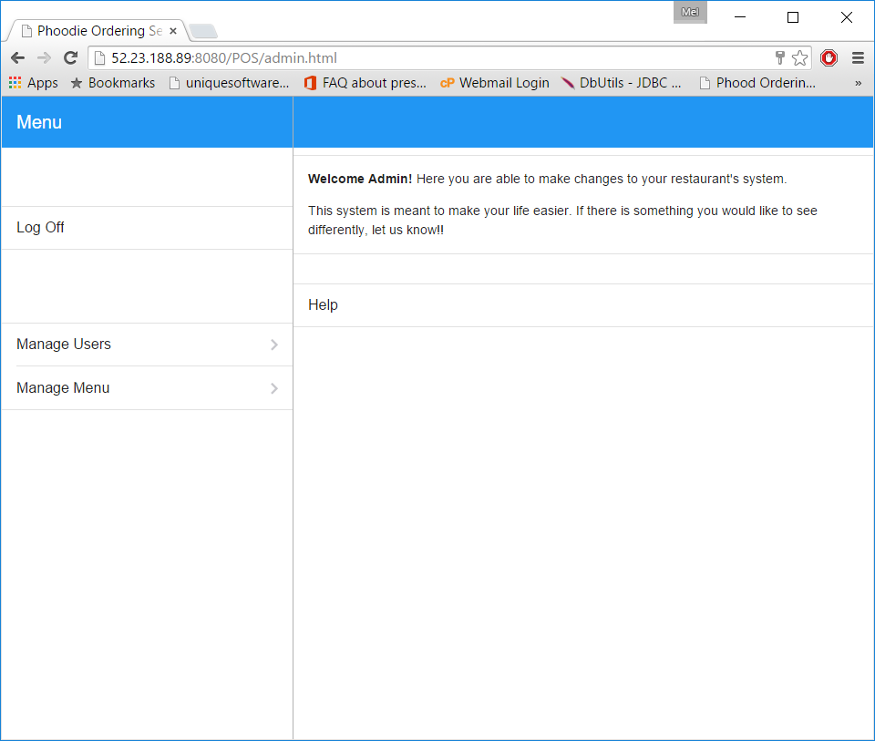

Test Case - Add User

1. Click on Manage User on left



1. Click on Add User

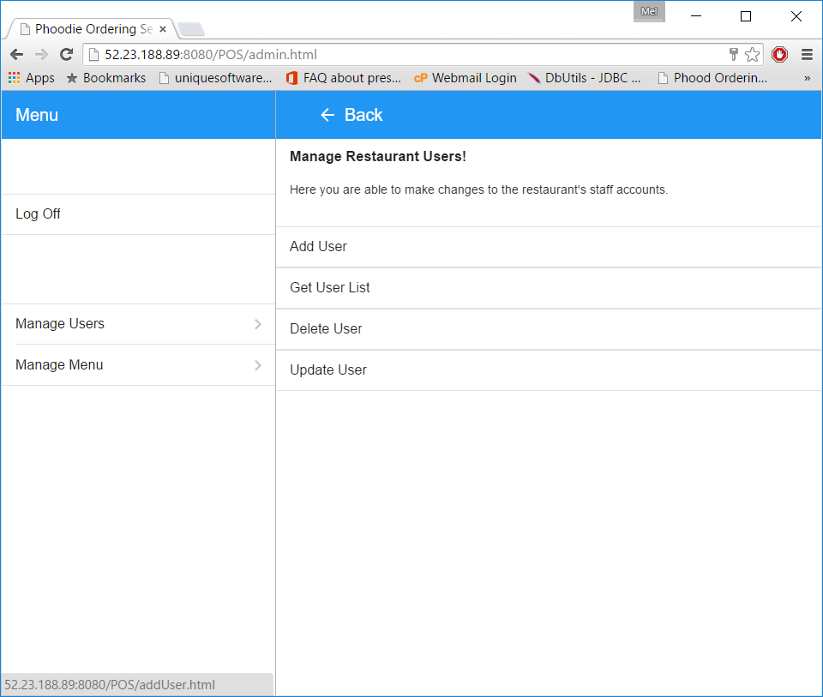

1. Add User

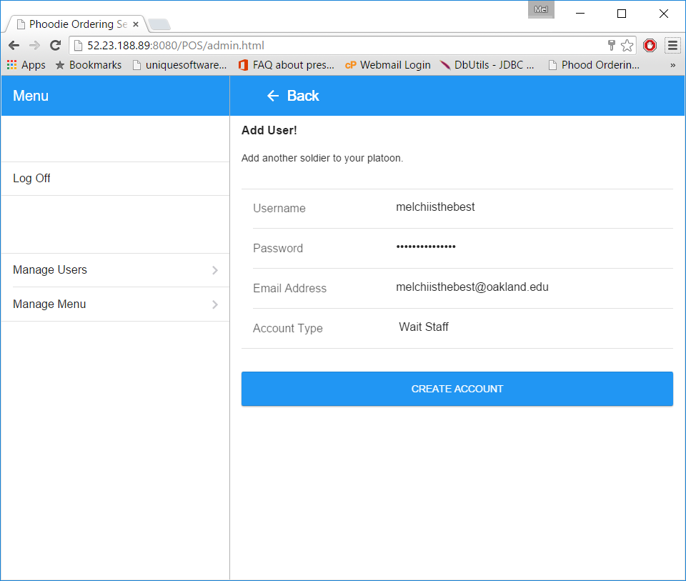

1. Success

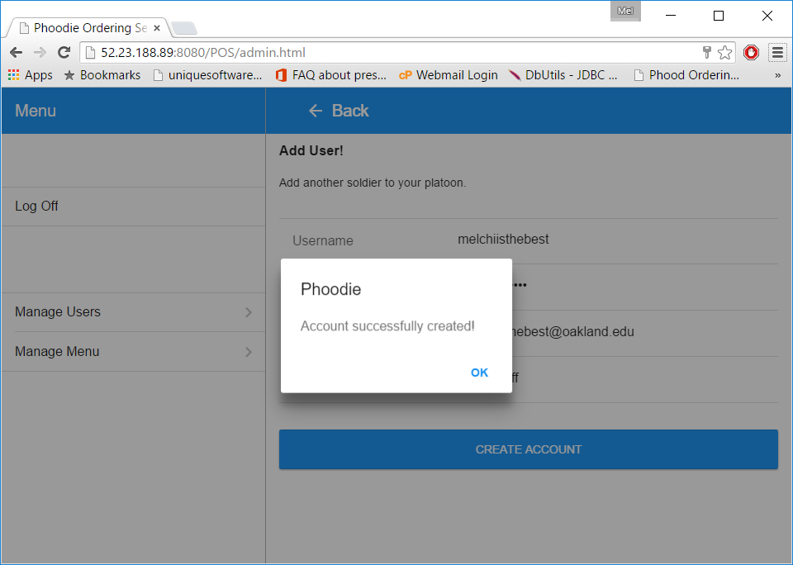

1. Check if worked

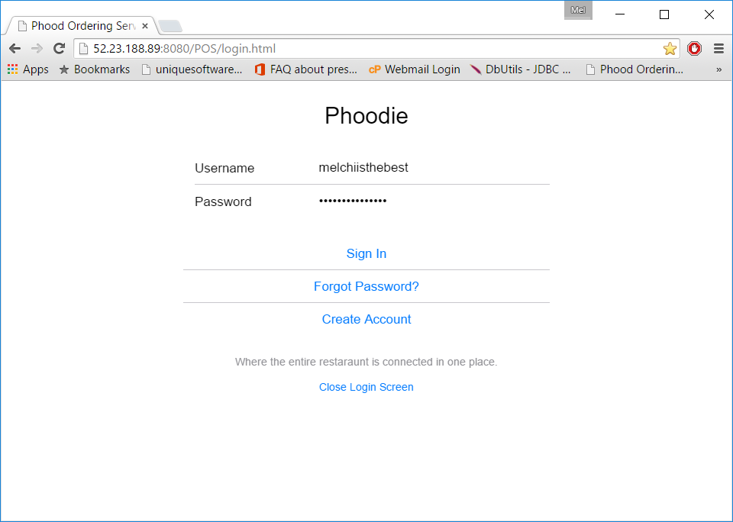

1. Success!

Test Case - Create Email

1. Click on Create Account

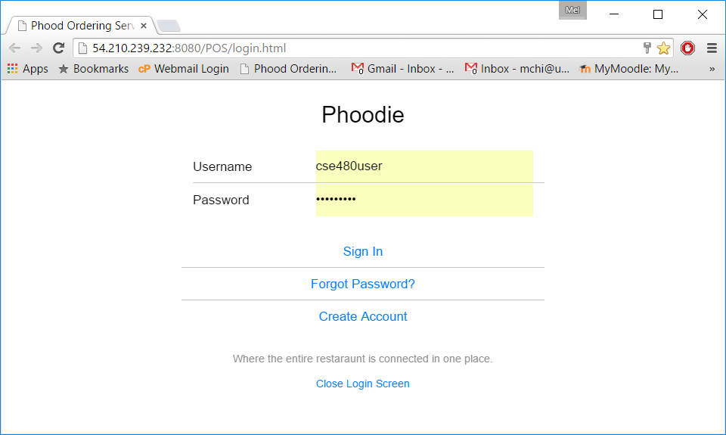

1. Enter Data (cse480user///12345678//jchi@oakland.edu)

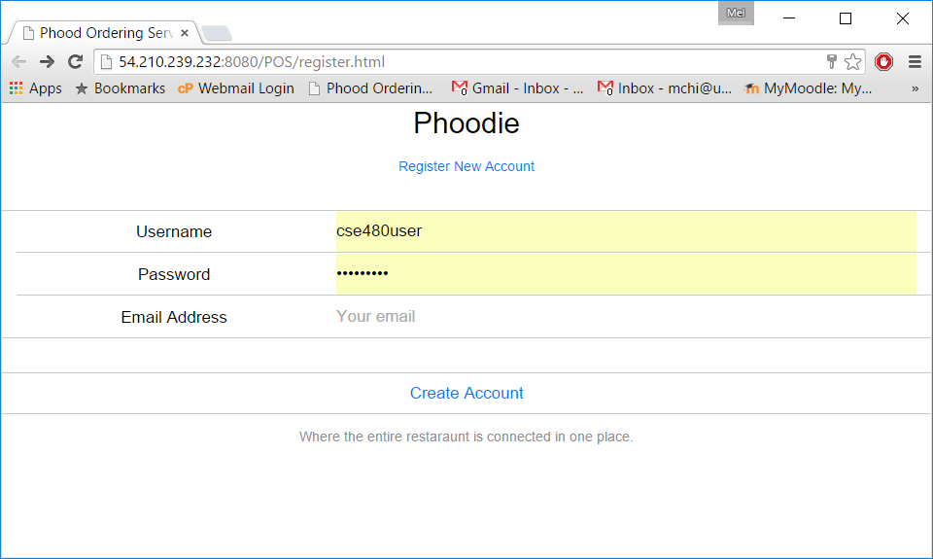

1. Get email to verify

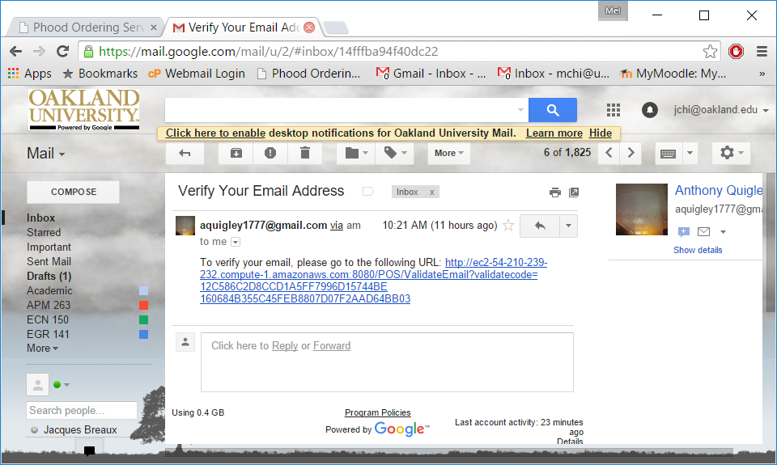

1. Click link to get verified

Test Case - Login Correctly

1. Login Info
2. Success

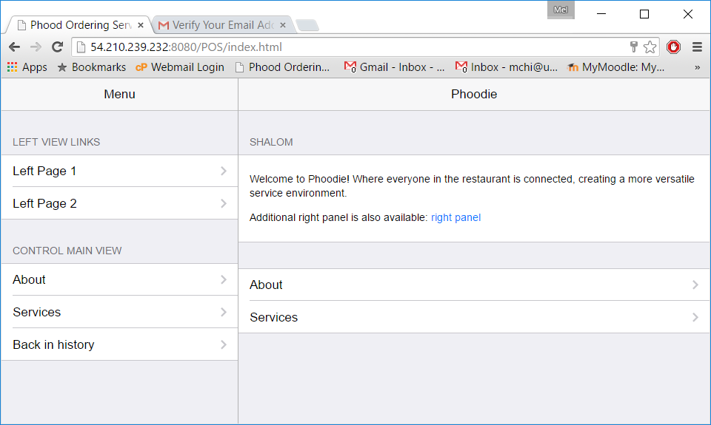

Test Case Login Fail

1. Login with incorrect info

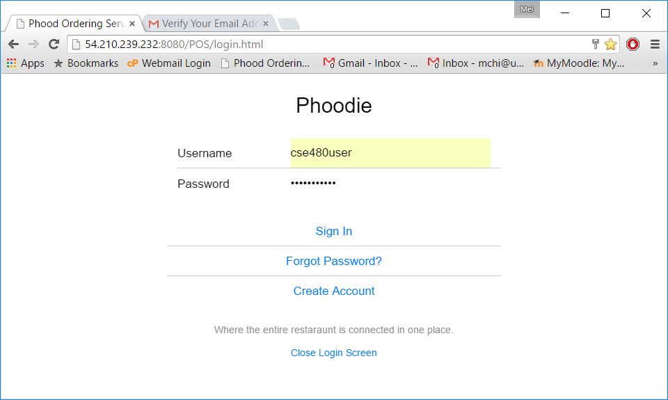

1. Fail

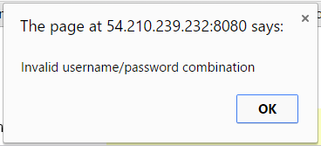

Test Case Remember Password

1. CLick forget Password

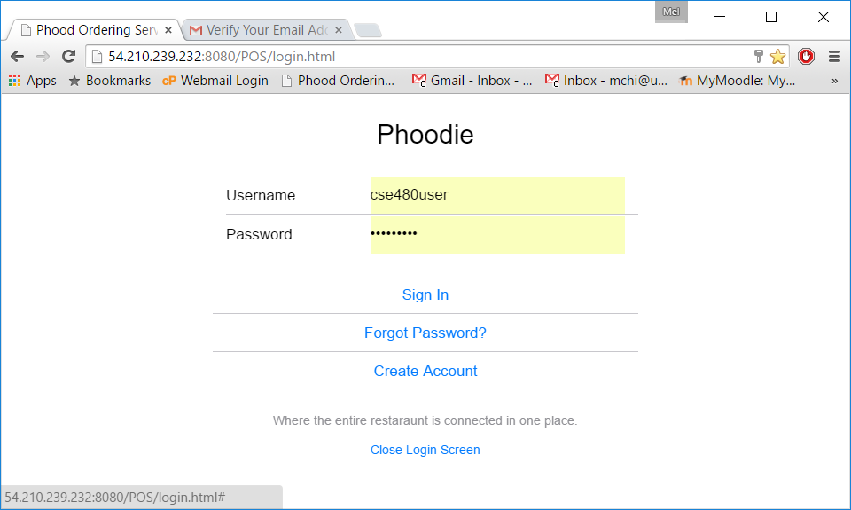

1. Enter email [jchi@oakland.edu](mailto:jchi@oakland.edu)

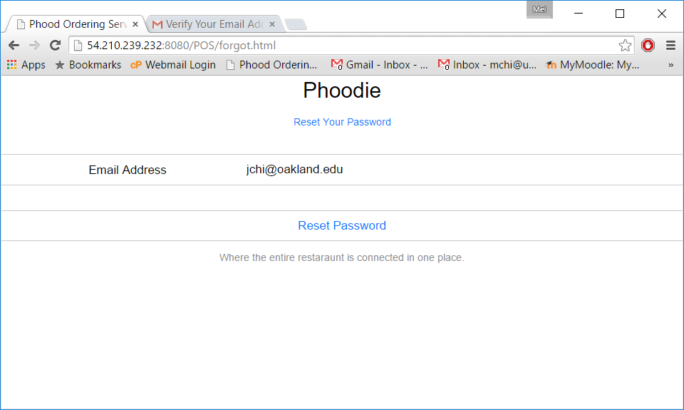

1. get resetted password

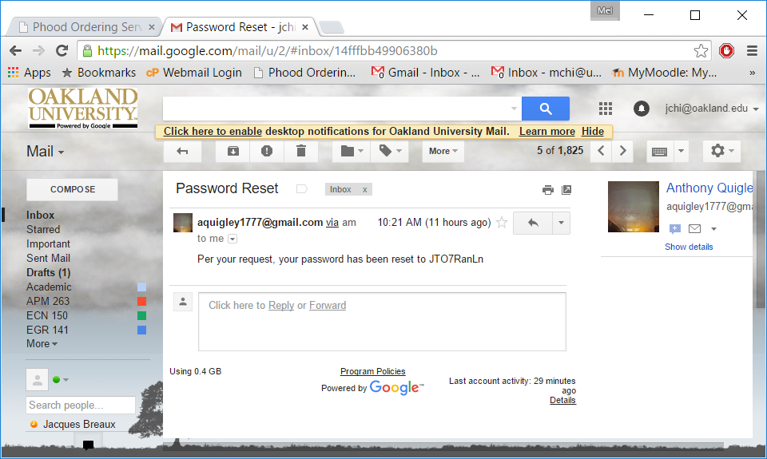

Test Case Duplicate Account

1. Register account [jchi@oakland.edu](mailto:jchi@oakland.edu)



1. Failure

